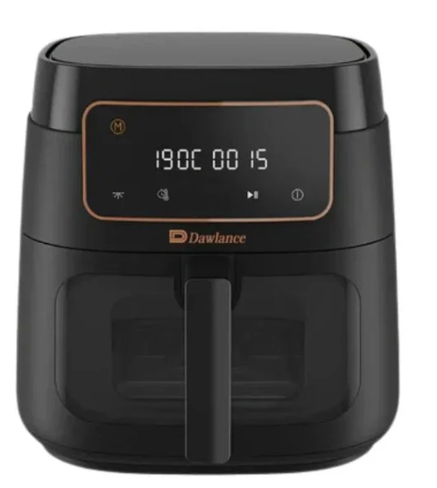

Dawlance Air Fryer
Rs.10,305
The Dawlance Air Fryer is designed for healthy, low-oil cooking using rapid hot-air circulation technology. It allows frying, baking, roasting, and grilling with minimal oil while maintaining crispy texture and fast cooking performance.

Specifications
- Type: Countertop Air Fryer
- Power: 1500 Watts
- Capacity: 3.5 Liters
- Temperature Control: 80-200°C
- Timer: 1-30 Minutes
- Voltage: 220-240V

Key Features
- Healthy cooking with minimal oil
- Crispy texture and fast cooking
- Easy-to-use digital interface
- Large capacity for family meals
- Non-stick coating for easy cleaning
- Safety features and automatic shut-off

